**ASSIGNMENT – 3**

**Program using python**

**Code:**

x=input("Enter Value:")

light=int(x)

while True:

if light>=1 and light<=10:

print('Green light')

light+=1

elif light<=20:

print('Yellow light')

light+=1

elif light<=30:

print('Red light')

light+=1

else:

light=0

break

**OUTPUT:**

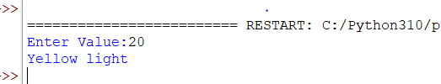

**Blinking LED and Traffic lights using Raspberry pi.**

**Code**

import RPi.GPIO as GPIO

import time

#assign numbering for the GPIO using BCM

GPIO.setmode(GPIO.BCM)

#assingn number for the GPIO using Board

#GPIO.setmode(GPIO.BOARD)

cnt = 0

# change LED status every 1 seconds

CHECK_FREQ = 1

RED_LED = 4

GPIO.setup(RED_LED, GPIO.OUT)

While True:

if cnt == 0 :

GPIO.output(RED_LED, False)

cnt = 1

else:

GPIO.output(RED_LED, True)

cnt = 0

Time.sleep(CHECK_FREQ)

GPIO.cleanup()